**Experiment No 7**

**Name: Arya Manoj Madhavi**

**Div: D15B**

**Roll No.:31**

**Batch B**

**AIM: Installing SonarQube from the Docker Image**

$ docker run -d --name sonarqube -e SONAR_ES_BOOTSTRAP_CHECKS_DISABLE=true -p 9000:9000

Sonarqube:latest

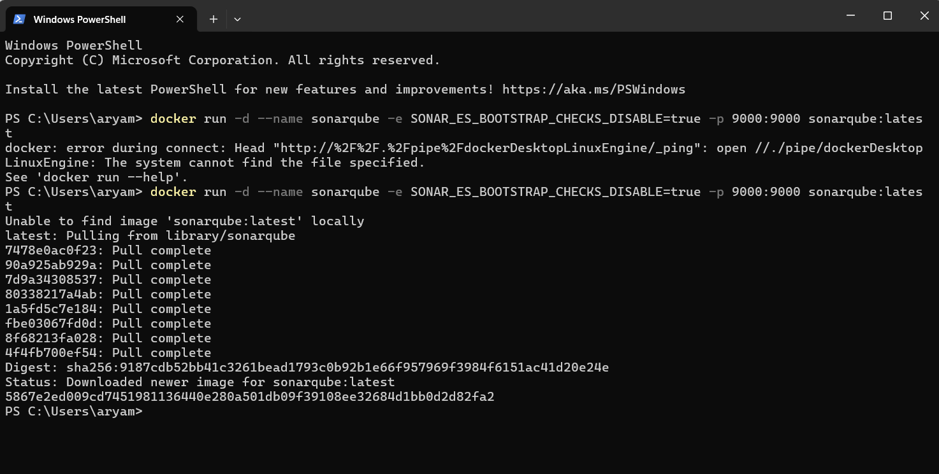



**go to the SonarQube page by typing:**

http://localhost:9000/ on your browser.

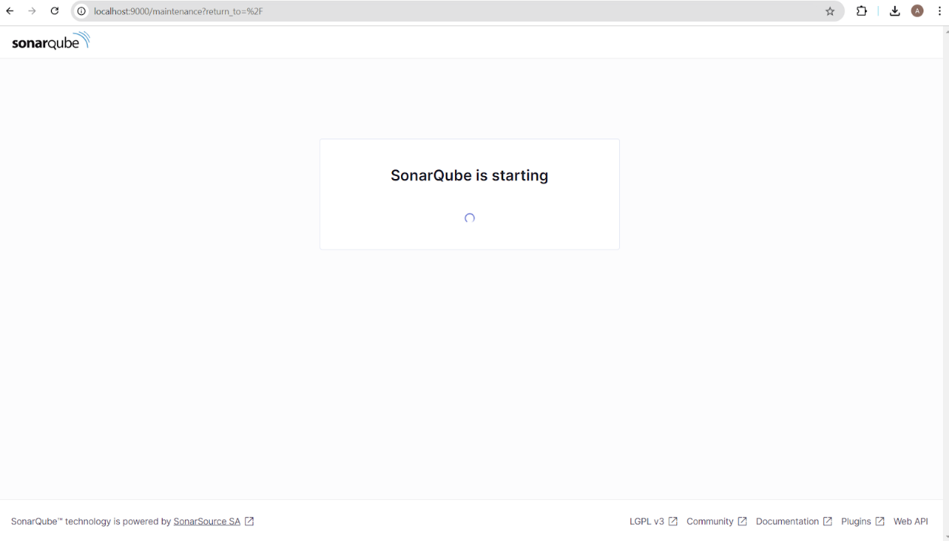

**Installation is successful if you see this page**

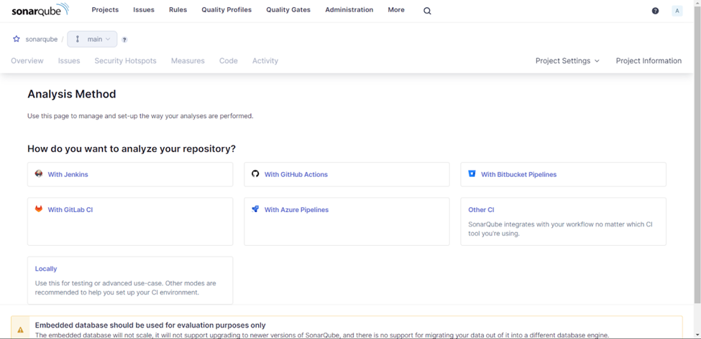

**Update to new password**

**Create project manually:**

Here project name is “AdDevops”

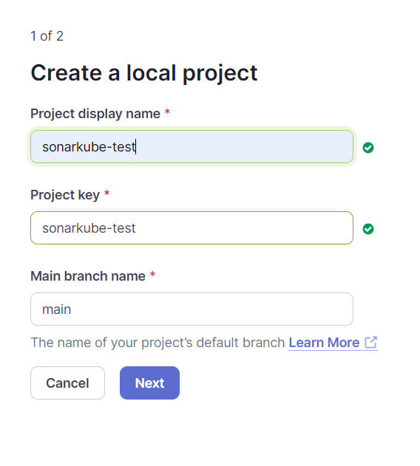

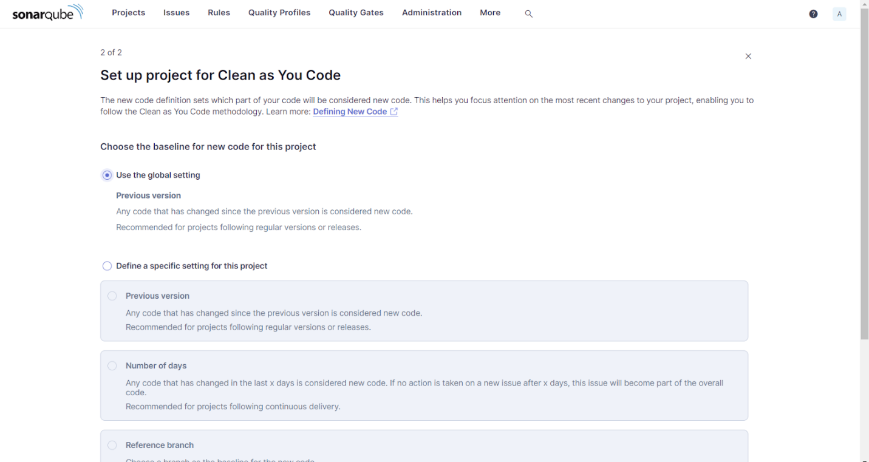

**open Jenkins**

Go to Dashboard ->Manage Jenkins -> Plugin Manager and search for

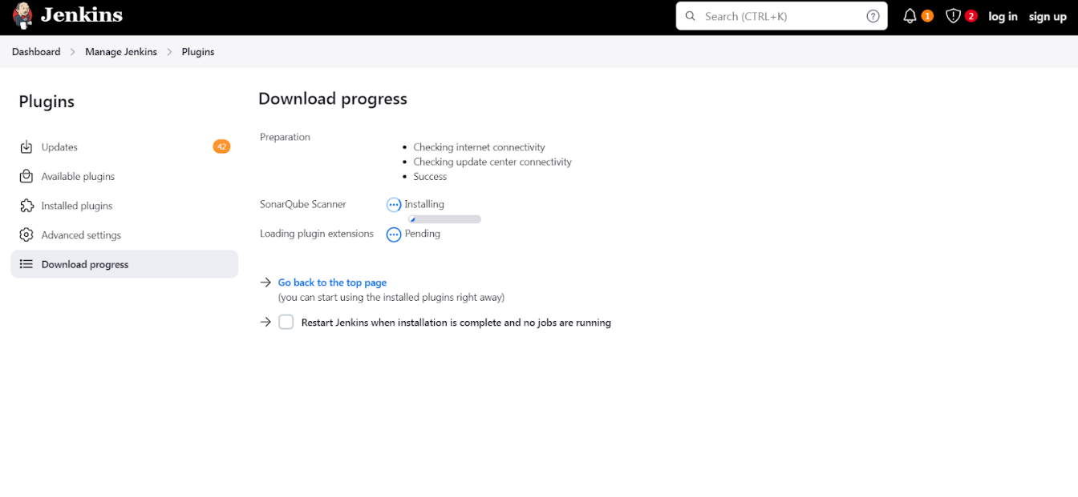

SonarQube Scanner under Available plugins for Jenkins and install without restart

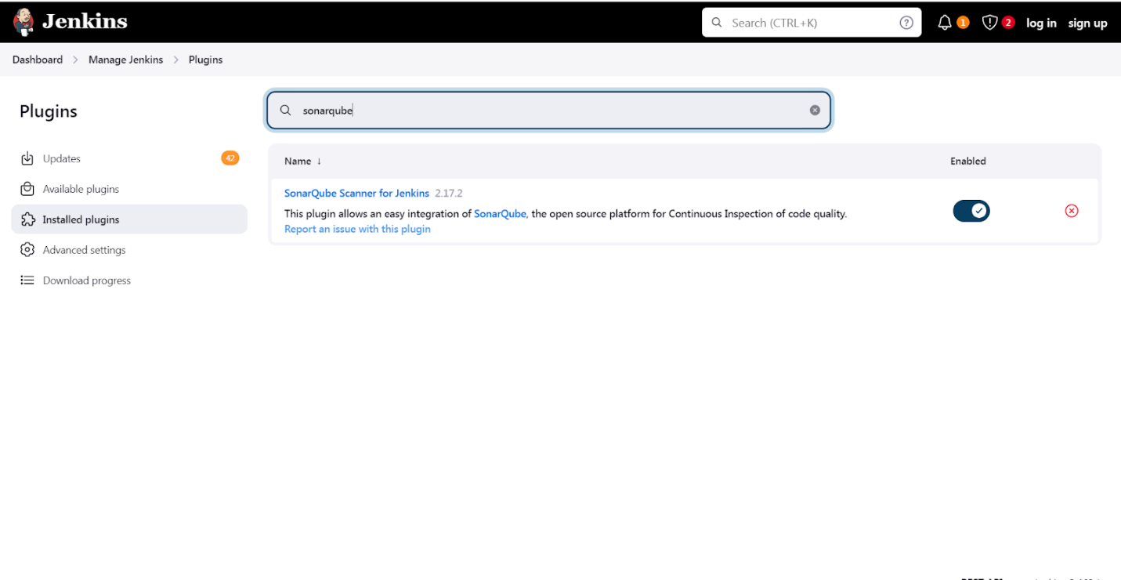

**Under Jenkins** ,

Dashboard -> Manage Jenkins -> Configure System ,

Look for SonarQube Servers and enter the details. Enter the Server Authentication Token

if needed.

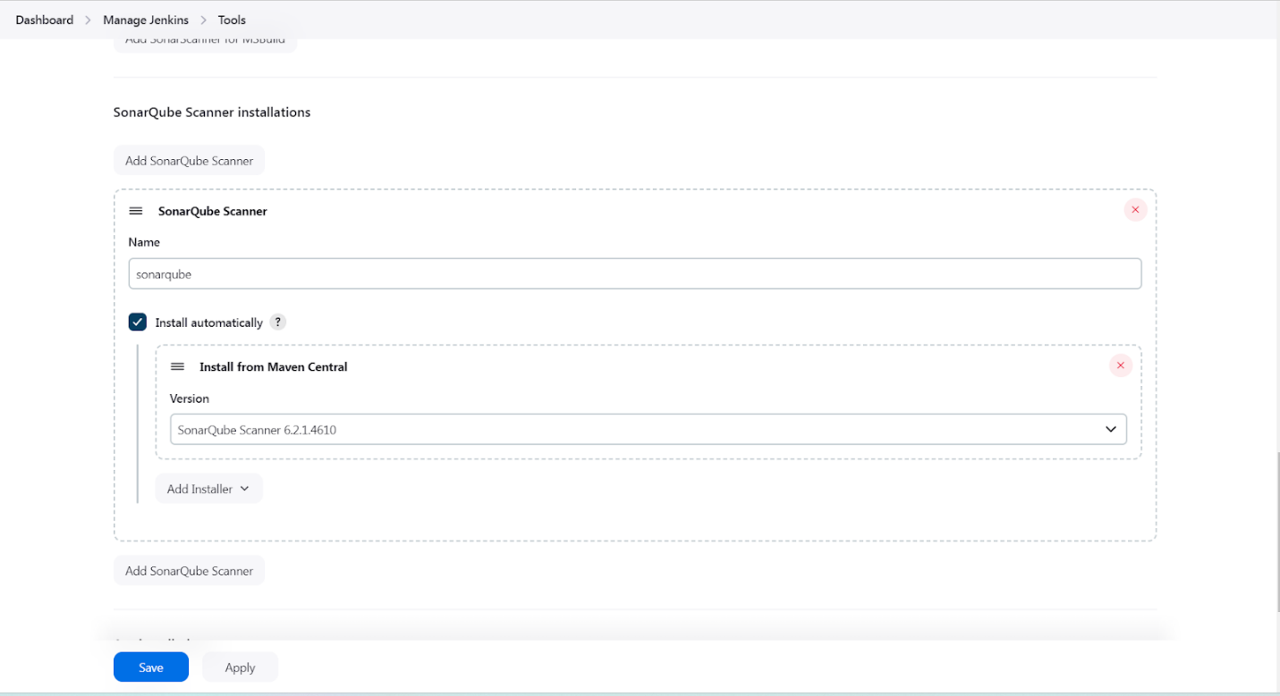

Search SonarQube Scanner under Dashboard -> Manage Jenkins -> Global

Tool Configuration.

**Choose the latest configuration and choose Install Automatically.**

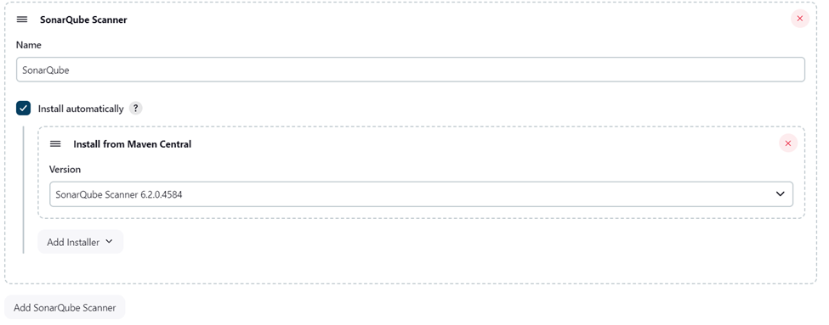

**create a New Item in Jenkins, choose a freestyle project.**

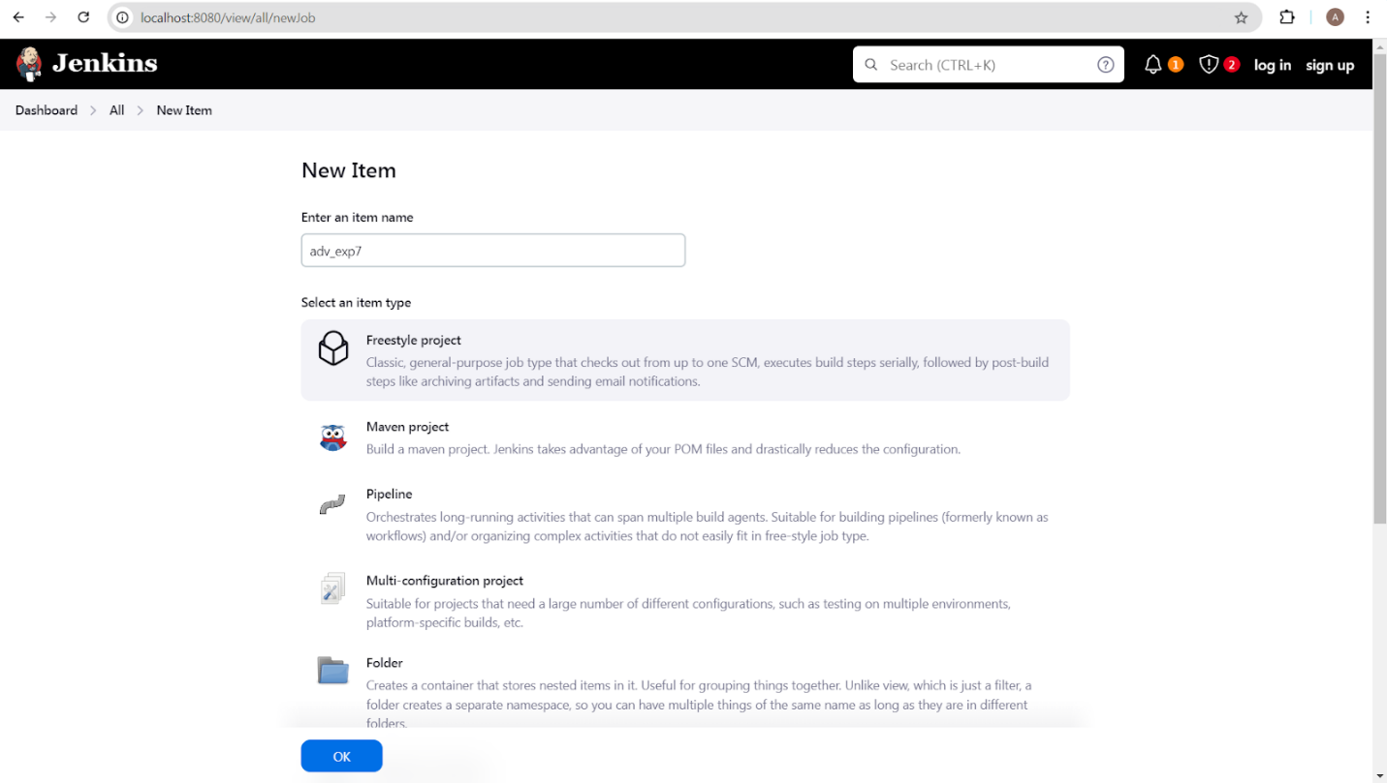

**Choose this GitHub repository in Source Code Management.**

https://github.com/shazforiot/MSBuild_firstproject.git

Under Build ->Execute SonarQube Scanner, enter these Analysis

properties. Mention the SonarQube Project Key, Login, Password, and Host

URL.

sonar.projectKey=AdDevops

sonar.login=admin

sonar.password=abc

sonar.hosturl=<http://localhost:9000/>

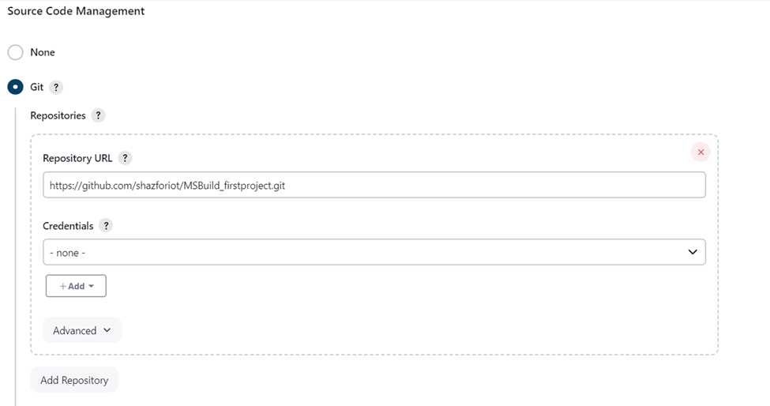

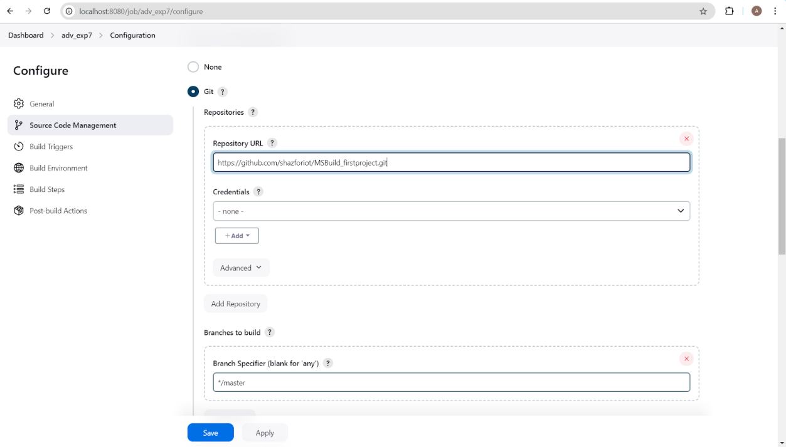

Go to http://localhost:9000/ and enter your previously created username.

**Go to Permissions and grant the Admin user Execute Permissions.**

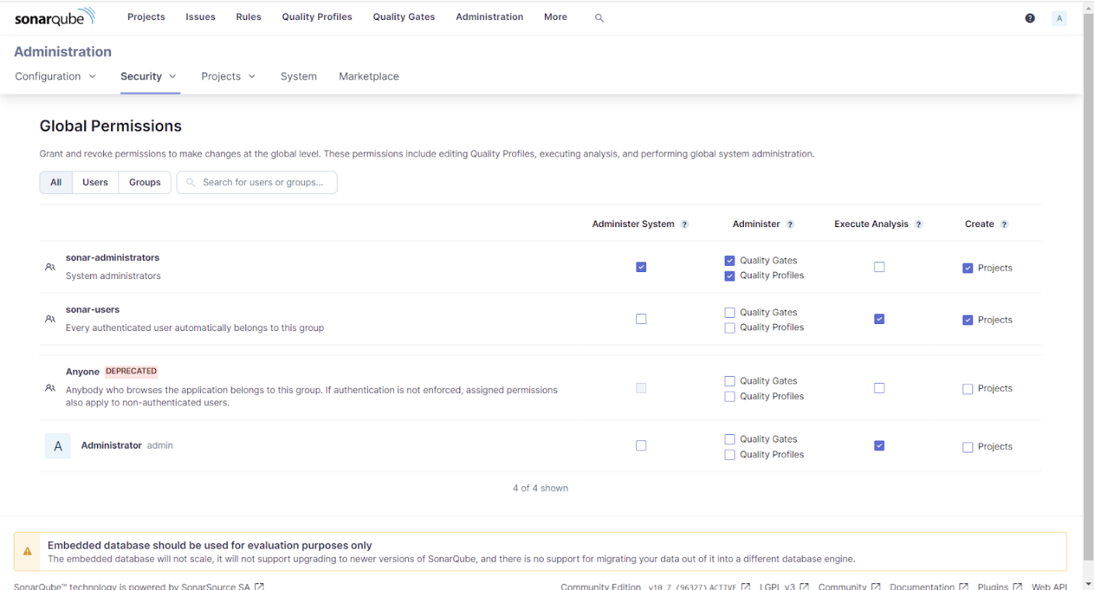

**Build and Run:**

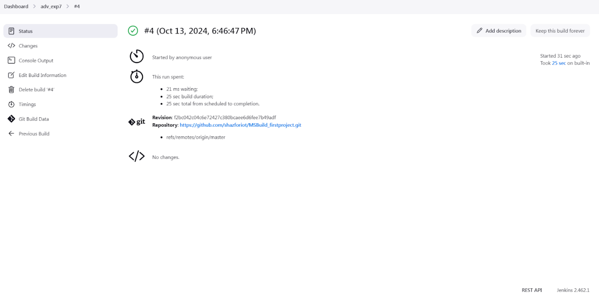

**Console Output:** 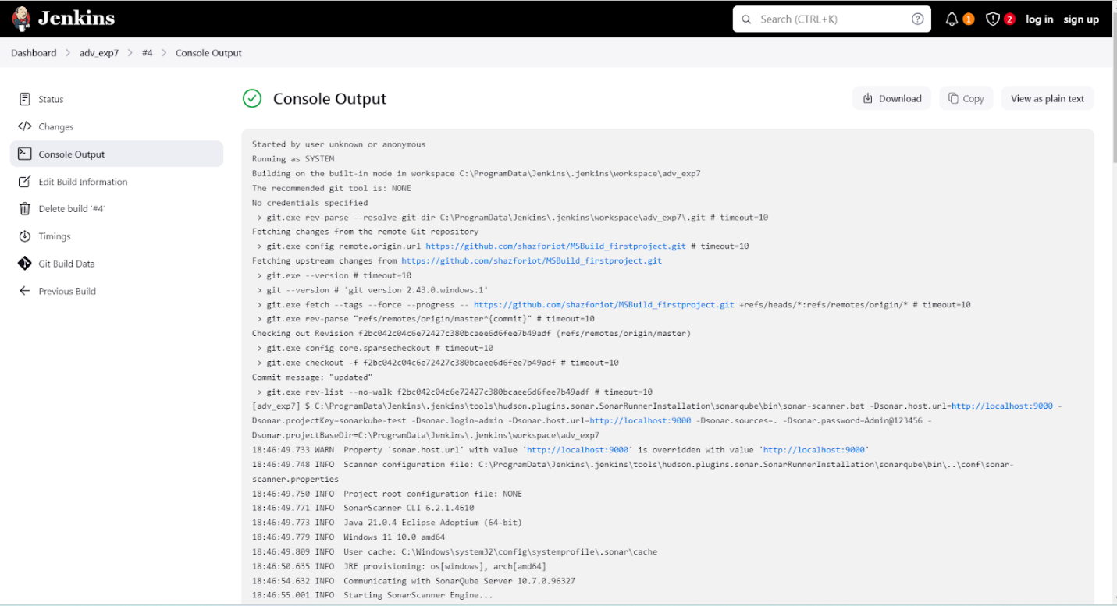

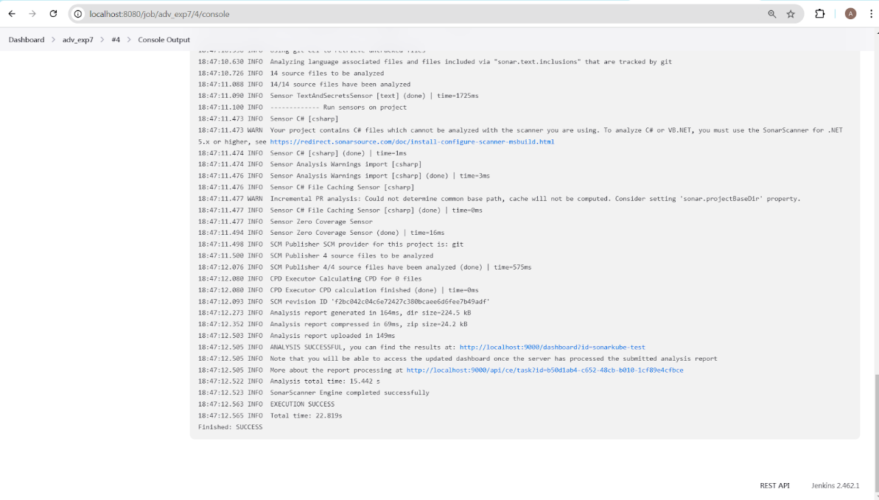

**Project on sonarqube:**

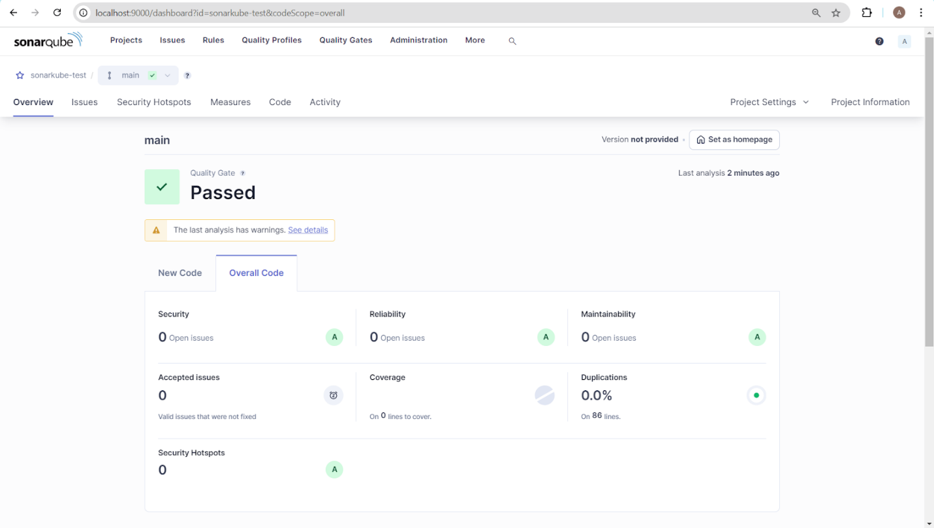

**Conclusion:**

Thus, we have successfully installed SonarQube using a Docker image, providing a seamless setup for continuous code quality analysis. This approach simplifies the deployment process, ensures easy scalability, and enhances development workflows with robust code review and testing capabilities in a containerized environment.